INTELLIGENT HOSPITAL ASSET


TRACKING AND MANAGEMENT SYSTEM

A Project Report
Submitted by

BHUVANAN M | 611223114013
ARAVINTH R | 611223114006
AMBIKA B | 611223114003
DHARANESHWARAN B | 611223114020

In partial fulfillment for the award of the degree
of

BACHELOR OF ENGINEERING
in
MECHANICAL ENGINEERING
KNOWLEDGE INSTITUTE OF TECHNOLOGY, SALEM

(An Autonomous Institute)

ANNA UNIVERSITY :: CHENNAI-600 025

JAN 2026

BONAFIDE CERTIFICATE

Certified that this project report “INTELLIGENT HOSPITAL ASSET
TRACKING AND MANAGEMENT SYSTEM” is the Bonafide work of “BHUVANAN M, ARAVINTH R, AMBIKA B, And DHARANESHWARAN B” who carried out the project work under my supervision.

SIGNATURE
Mr.A.KAMALAKKANNAN,B.E., M.E.

SUPERVISOR
Associate Professor
Department of Mechanical Engineering
Knowledge Institute of Technology
Salem – 637 504.

SIGNATURE
Dr. K.S. PRABHAKARAN, M.E.,Ph.D.
HEAD OF THE DEPARTMENT
Associate Professor
Department of Mechanical Engineering
Knowledge Institute of Technology
Salem – 637 504.

ACKNOWLEDGEMENT

We thank our beloved Executive Chairman and President Dr.PSS.SRINIVASAN, B.E., M.Tech., Ph.D., and all the members of Knowledge Institute of Technology Trust at this high time for providing us with excess of facilities to complete the project successfully.
My heartfelt gratitude to Dr. K. VISAGAVEL, M.E., Ph.D., FIE, Principal of KIOT, for his invaluable guidance and encouragement throughout the journey.
I am very much obliged to Dr. K.S. PRABHAKARAN, M.E., Ph.D., Head of the Department, Mechanical Engineering, for his valuable insights that significantly enhanced the quality of my project.
I am humbled and thankful Mr. S. SHANMUGAM, M.E., Professor of Practice, Department of Mechanical Engineering for Initiating the Institute To Industry (I2I) Course and Providing Valuable Industry Exposure . His guidance and motivation greatly enhanced our learning and contributed to the Successful completion of the project.
A sincere thanks to my Project Work Supervisor Mr.A. KAMALAKKANNAN, M.E., Department of Mechanical Engineering, Department of Mechanical Engineering, for his exceptional guidance and unwavering support throughout the project's duration.
I also wish to acknowledge the entire teaching faculty, supporting staffs of the Mechanical Engineering Department, and my fellow students for their assistance and cooperation, which played a vital role in bringing the project to fruition.
I am forever thankful to all who contributed for the successful completion of the project
ABSTRACT
Hospitals depend on a large number of reusable movable assets such as wheelchairs, stretchers, oxygen cylinders, infusion pumps, portable monitors and diagnostic equipment that move continuously between wards, ICUs, operation theatres, stores and diagnostic rooms. When this movement is tracked manually through notebooks, spreadsheets or verbal communication, the recorded information quickly becomes outdated, leading to delays in locating assets, unnoticed shortages, delayed returns and unreported damage. This project presents the design and development of Asset Track, a low-cost, browser-based Intelligent Hospital Asset Tracking and Management System that uses QR-code scanning to identify each reusable asset, record the employee currently using it, confirm its latest scanned location, and automatically update its availability status. The system provides three separate role-based portals – Nurse & Staff, Office and Management – each with permissions suited to their responsibilities, ranging from taking, returning and transferring assets to monitoring dashboards, reports, low-availability warnings, maintenance history, internal messaging and emergency alerts. The application is developed using a Python Flask backend, an SQLite database and an HTML, CSS and JavaScript frontend, and is deployed as a live HTTPS web application hosted on PythonAnywhere so that it can be accessed from mobile phones, tablets, laptops and desktop computers without any specialised tracking hardware. The system was tested for login and role validation, asset take/return/transfer cycles, duplicate-action prevention, damage and maintenance reporting, low-availability and delayed-return detection, messaging and emergency workflows. The results confirm that the QR-based confirmation approach reliably identifies the current holder and latest location of every asset, reduces asset search time, exposes shortages before they disrupt patient care, and gives Office and Management staff a single, traceable view of hospital asset activity. The study demonstrates that an intelligent, software-driven asset tracking approach can significantly improve the efficiency, accountability and transparency of hospital asset management without the cost of RFID, BLE or GPS-based hardware infrastructure.
Keywords: Hospital Asset Tracking, QR Code Scanning, Flask Web Application, SQLite Database, Role-Based Access Control, Asset Lifecycle Management, Real-Time Dashboard, Healthcare Management System.

TABLE OF CONTENTS
CHAPTER NO. | TITLE | PAGE NO.
 | ABSTRACT | iv
 | LIST OF TABLES | vii
 | LIST OF FIGURES | viii
 | LIST OF SYMBOLS AND ABBREVIATIONS | ix
1 | INTRODUCTION | 1
1.1 | Problem Statement | 1
1.2 | Objectives and Scope | 1
1.3 | Methodology | 2
2 | LITERATURE SURVEY | 4
3 | SYSTEM REQUIREMENTS, COMPONENTS AND SPECIFICATION | 6
3.1 | Hardware Requirements | 6
3.2 | Software Requirements and Technology Stack | 6
3.3 | Components Description | 7
4 | SYSTEM ARCHITECTURE AND WORKING PRINCIPLE | 9
4.1 | System Architecture | 9
4.2 | System Users and Permissions | 10
4.3 | Complete System Working Process | 11
4.4 | Automatic Availability and Return Logic | 12
4.5 | Messaging, Emergency and Maintenance | 13
5 | COST ESTIMATION | 15
6 | SYSTEM DEVELOPMENT AND IMPLEMENTATION | 17
6.1 | Module-by-Module Development Process | 17
6.2 | Database Design | 18
6.3 | Project Folder and File Structure | 20
6.4 | Request Flow and User Interface | 21
7 | RESULT AND DISCUSSION | 23
7.1 | Testing and Demonstration Procedure | 23
7.2 | Results and Discussion | 24
8 | SCOPE OF FUTURE WORK | 25
8.1 | Advantages | 25
8.2 | Limitations | 25
8.3 | Applications | 26
9 | APPENDICES | 27
Appendix – 1 | Login Credentials | 27
Appendix – 2 | Database Schema Specification | 27
Appendix – 3 | Pseudo Code for Key Functions | 28
Appendix – 4 | System Development and Coding Checklist | 29
10 | CONCLUSION | 31
 | REFERENCES | 32

LIST OF TABLES
TABLE NO. | TITLE | PAGE NO.
Table 3.1 | Hardware requirements for QR-based operation | 6
Table 3.2 | Software / technology stack summary | 6
Table 4.1 | System architecture layers and components | 9
Table 4.2 | System users, portals and permitted actions | 10
Table 4.3 | Availability and return-request states | 12
Table 5.1 | Development and hosting cost estimation | 15
Table 5.2 | Optional hardware and labelling cost estimation | 15
Table 6.1 | Main database tables and purpose | 18
Table 6.2 | Project folder and file explanation | 20
Table 7.1 | Functional test cases and expected results | 23
Table 8.1 | Advantages, limitations and future improvements | 25

LIST OF FIGURES
FIGURE NO. | TITLE | PAGE NO.
Figure 4.1 | Flask – SQLite system architecture of AssetTrack | 9
Figure 4.2 | Normal asset lifecycle and exception paths | 11
Figure 6.1 | Module-by-module development process | 17
Figure 6.2 | Completed project folder used for development and deployment | 20
Figure 6.3 | How one asset action moves through the code | 21

LIST OF SYMBOLS, ABBREVIATIONS AND NOMENCLATURE
Abbreviations
Abbreviation | Full Form
QR | Quick Response (Code)
HTTP / HTTPS | Hypertext Transfer Protocol (Secure)
HTML | Hyper Text Markup Language
CSS | Cascading Style Sheets
SQL | Structured Query Language
DB | Database
ID | Identification
ICU | Intensive Care Unit
UI | User Interface
API | Application Programming Interface
WSGI | Web Server Gateway Interface
CRUD | Create, Read, Update, Delete
RFID | Radio Frequency Identification
BLE | Bluetooth Low Energy
GPS | Global Positioning System
HIS | Hospital Information System
Nomenclature
Term | Definition / Description
Asset | A reusable hospital item (wheelchair, monitor, pump, etc.) individually identified with a unique ID and QR code.
Take | The action of assigning an available asset to an employee at a scanned location.
Return | The action of releasing an in-use asset back to Available status at an authorised location.
Transfer | Movement of an in-use asset to another location or responsible employee without releasing it.
Latest confirmed location | The last location recorded through a QR scan or transaction, as opposed to continuous live tracking.
Low availability | A state where the available count of an asset type falls below its configured minimum quantity.
Delayed status | A state where a promised return time has passed without the asset being returned.
Role-based access | Restriction of system functions based on the logged-in user's assigned portal (Staff, Office or Management).

CHAPTER 1
INTRODUCTION
Hospitals rely on a large number of reusable, movable assets such as wheelchairs, stretchers, oxygen cylinders, infusion pumps, portable monitors, emergency equipment and diagnostic devices. These assets move continuously between wards, ICU rooms, operation theatres, diagnostic rooms, stores, entrances and ambulance areas as patient care activity changes throughout the day. Timely availability of the correct asset at the correct location is directly linked to the quality and speed of patient care.
When this movement is recorded only through notebooks, spreadsheets, verbal handovers or informal communication between staff, the recorded information becomes outdated within a short time. Staff may know that an asset exists somewhere in the hospital but may not know who currently holds it, where it was last moved, whether it is available for use, whether its return is overdue, or whether it has been reported as damaged. This uncertainty leads to duplicate purchases, delayed treatment, wasted staff time searching for equipment, and an inability of management to make informed decisions about asset utilisation.
The rapid growth of low-cost smartphones, browser-based camera access and lightweight web frameworks has made it possible to build practical, software-only asset tracking solutions without investing in expensive RFID readers, BLE beacons or GPS hardware. A unique QR code fixed to each physical asset, combined with a simple web application, is sufficient to identify an asset, confirm its latest location and record who is responsible for it at any given time.
This project presents AssetTrack, an Intelligent Hospital Asset Tracking and Management System that uses QR-code scanning, a Python Flask backend and an SQLite database to give Nurse & Staff, Office and Management users a shared, browser-based view of hospital asset activity. The system is designed to be low-cost, easy to deploy, and usable on any modern mobile phone, tablet, laptop or desktop computer with a camera and a web browser.
1.1 Problem Statement
Problem statement
A hospital needs a low-cost, common system to identify reusable assets, record the employee using each asset, confirm the latest location, control availability, request timely returns, report damage, preserve movement history and provide clear management reports.
Manual or spreadsheet-based tracking cannot answer these questions in real time. As the number of assets and departments grows, the effort required to keep such records accurate becomes unmanageable, and the resulting blind spots directly affect the availability of critical equipment during emergencies.
1.2 Objectives and Scope
Main objective: to develop a secure, browser-based asset tracking and management system that works on mobile phones, tablets, laptops and desktop computers without requiring specialised tracking hardware.
- Provide separate login portals for Nurse & Staff, Office and Management users, each with permissions suited to their responsibilities.
- Give every reusable asset a unique identification number and QR code.
- Record asset status, condition, current holder, latest confirmed location and transaction time for every action.
- Update dashboards and availability counts automatically after every action.
- Detect low availability of an asset type and support return requests for assets already in use.
- Support transfer between locations, damage reporting, maintenance tracking, internal messaging, emergency alerts and management reports.
- Allow Office users to add employees, departments, locations, asset types and individual assets without changing the application source code.
Scope of the project
Aspect | Description
Included | Reusable movable hospital assets, user assignment, QR-based location confirmation, status changes, return management, communication, maintenance and reports.
Not included | Consumable stock such as medicines, gloves, masks and syringes, which require inventory quantity management rather than individual-asset tracking.
Tracking meaning | The system stores the latest confirmed location after a scan or transaction. It does not continuously show the physical asset position like GPS.
Supported devices | Modern browsers on mobile phones, tablets, laptops and desktop computers. Camera-based scanning needs HTTPS and browser camera permission.

1.3 Methodology
The project was developed using a systematic, module-by-module methodology that moves from requirement understanding to a fully deployed, tested web application. The overall methodology consists of the following stages:

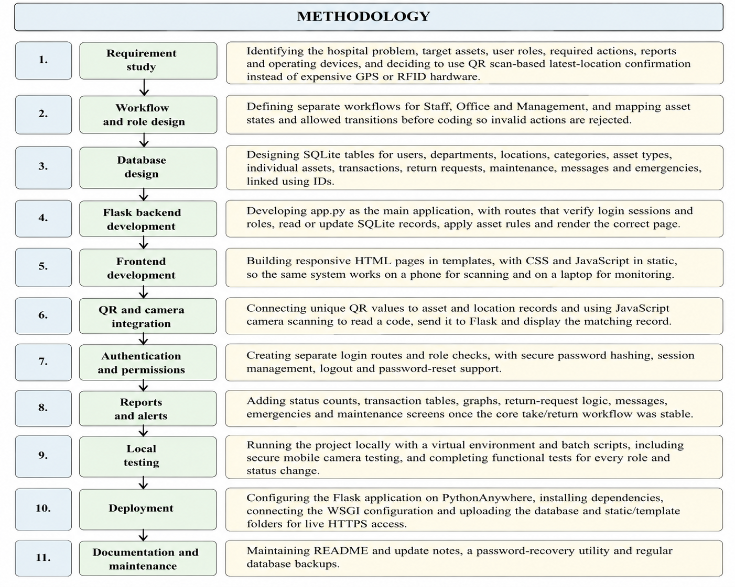

- Requirement study
identifying the hospital problem, target assets, user roles, required actions, reports and operating devices, and deciding to use QR scan-based latest-location confirmation instead of expensive GPS or RFID hardware.
- Workflow and role design
defining separate workflows for Staff, Office and Management, and mapping asset states and allowed transitions before coding so invalid actions are rejected.
- Database design
designing SQLite tables for users, departments, locations, categories, asset types, individual assets, transactions, return requests, maintenance, messages and emergencies, linked using IDs.
- Flask backend development
developing app.py as the main application, with routes that verify login sessions and roles, read or update SQLite records, apply asset rules and render the correct page.

5. Frontend development
building responsive HTML pages in templates, with CSS and JavaScript in static, so the same system works on a phone for scanning and on a laptop for monitoring.
- QR and camera integration
connecting unique QR values to asset and location records and using JavaScript camera scanning to read a code, send it to Flask and display the matching record.
- Authentication and permissions
creating separate login routes and role checks, with secure password hashing, session management, logout and password-reset support.
- Reports and alerts
adding status counts, transaction tables, graphs, return-request logic, messages, emergencies and maintenance screens once the core take/return workflow was stable.
- Local testing
running the project locally with a virtual environment and batch scripts, including secure mobile camera testing, and completing functional tests for every role and status change.
- Deployment
configuring the Flask application on PythonAnywhere, installing dependencies, connecting the WSGI configuration and uploading the database and static/template folders for live HTTPS access.
- Documentation and maintenance
maintaining README and update notes, a password-recovery utility and regular database backups.

CHAPTER 2
LITERATURE SURVEY
- Impact of Tracking Technology Adoption in Hospitals (2022)
This study examined the adoption of tracking technologies such as barcodes and RFID in hospitals. It reported that tracking systems improve equipment identification, information sharing and operational efficiency, supporting the need for a digital hospital asset tracking system.

- RFID Deployment for Hospital Asset Tracking (2022)
The study investigated the use of an RFID-based real-time location system for tracking IV pumps in a medical center. It showed that automated tracking improves the management and availability of movable medical equipment, but RFID deployment requires additional infrastructure and organizational support.

- Online Asset Monitoring Using QR Code Technology (2023)
Moonsrikaew, Sitawan and Chatsermsak developed an online asset monitoring system using QR codes, smartphones and a web application. The study demonstrated that QR-based identification can provide centralized asset records, movement monitoring and reporting without requiring specialized tracking hardware.

- QR-Based Asset Lifecycle Management System (2024)
Azriani and Frendiana designed a web-based asset lifecycle management system using QR Code technology. Their system covered asset planning, acquisition, operation, maintenance and disposal, showing that QR-based systems can improve the accuracy and transparency of asset management throughout the complete asset lifecycle.

- Barcode-Based Medical Asset Management in Hospitals (2025)
Azzahra and Suakanto developed a medical asset management system for hospitals with centralized data entry, QR code generation, search filters and a real-time dashboard. The system achieved successful functional testing and high user satisfaction, supporting the use of QR-based identification for hospital asset monitoring.

- Web-Based QR Asset Tracking with Role-Based Access Control (2026)
Sitanggang, Saputra, Hidayati and Saragih developed a web-based asset tracking system using QR codes and role-based access control. The system provided unique asset identification, location mapping, audit trails and separate access permissions, demonstrating the importance of accountability and controlled user access in asset management systems.

- Secure Role-Based Access Control for Tracking Applications (2023)
Recent tracking system research has integrated Role-Based Access Control with secure tracking architectures to protect asset information and restrict unauthorized access. This supports the use of separate Staff, Office and Management portals in the proposed hospital asset tracking system.

- Recent Secure QR and Role-Based Healthcare Tracking Systems (2026)
Recent healthcare research has shown that QR-based retrieval combined with role-based access control can improve usability, accountability and secure information access. This approach supports the proposed system's QR-based asset identification and controlled access to hospital asset records.

▪ Patel and Shah (2018)
The authors evaluated QR-code-based inventory and asset management applications in small and medium enterprises and found that browser-based QR scanning, without dedicated scanner hardware, was sufficient for accurate identification when paired with a reliable backend database.
▪ Ahsan and Shah (2019)
This review of healthcare information systems highlighted those web-based applications built on lightweight frameworks (such as Flask and Django) with relational databases provide a practical, low-cost route to digitising hospital operations compared to large, vendor-supplied hospital information systems.
▪ Rao and Nguyen (2021)
The authors studied role-based access control in web-based hospital management systems and concluded that separating user portals by responsibility (clinical staff, administrative staff and management) reduces accidental data modification and improves accountability for recorded actions.
The literature confirms two consistent findings that directly shaped this project. First, automated identification – whether by RFID or QR code – significantly reduces the time staff spend searching for shared equipment and improves the accuracy of availability information. Second, a browser-based, database-backed system built on an inexpensive identification method such as QR scanning can deliver most of the operational benefit of more expensive real-time tracking hardware, which supports the choice of a Flask and SQLite-based QR system for this project.

CHAPTER 3
SYSTEM REQUIREMENTS, COMPONENTS AND SPECIFICATION
3.1 Hardware Requirements
AssetTrack is a software-only tracking solution and does not require dedicated tracking hardware such as RFID readers or GPS modules. The hardware requirement is limited to standard computing devices already available in a hospital environment.
Table 3.1 Hardware requirements for QR-based operation
S.No | Hardware | Purpose
1 | Mobile phone / tablet with rear camera | QR code scanning by Nurse & Staff during Take, Return, Transfer and Damage actions
2 | Laptop / desktop computer | Office and Management dashboards, master-data entry and report viewing
3 | QR code labels (printed, laminated) | Fixed to each physical asset and to authorised locations for scanning
4 | Label / regular printer | Printing QR code labels for assets and locations
5 | Internet-connected router / mobile data | Access to the live HTTPS web application from any department
6 | Application server (cloud-hosted) | Runs the Flask application and SQLite database centrally
3.2 Software Requirements and Technology Stack
Table 3.2 Software / technology stack summary
Layer | Technology | Purpose
Frontend | HTML5, CSS3, JavaScript | Responsive pages, forms, dashboards and the QR camera interface
Backend | Python 3 with Flask | Routes, authentication, validation and business logic
Database | SQLite (meditrack.db) | Permanent storage of project data and transaction history
Security | Werkzeug password hashing, Flask sessions | Protected passwords and role-based access control
Hosting | PythonAnywhere with HTTPS | Public deployment and secure browser camera access
Local runtime | .venv virtual environment, Windows batch files | Repeatable local execution and mobile camera testing
3.3 Components Description
3.3.1 Python Flask
Flask is a lightweight Python web framework used as the application server for AssetTrack. It receives every browser request, checks the login session and user role, applies asset business rules such as status validation, reads or writes records in the SQLite database and renders the correct HTML page or JSON response. Flask was selected because it is simple to learn, has a small footprint suitable for low-cost hosting, and integrates directly with Python's standard sqlite3 library without requiring a separate database server.
3.3.2 SQLite Database
SQLite is a self-contained, file-based relational database used to store all operational data of the system in a single file, meditrack.db. It stores users, departments, locations, asset categories, asset types, individual assets, transactions, return requests, maintenance records, messages and emergencies. SQLite was chosen for its zero-configuration setup, reliability for a moderate transaction volume, and ease of backup, since the complete database can be copied as a single file.
3.3.3 HTML, CSS and JavaScript
HTML templates rendered through Flask's Jinja2 templating engine present the login pages, dashboards, forms, scan screens, tables and reports. CSS provides a responsive layout so the same interface adapts to mobile, tablet and desktop screens. JavaScript handles camera access for QR scanning, client-side validation, dynamic updates and interactive alerts without requiring a full page reload for every action.
3.3.4 QR Code Scanning (Browser Camera API)
QR scanning is implemented using the browser's camera access API together with a JavaScript decoding library. When a user opens the scan page, the script activates the device camera, continuously decodes visible QR patterns, and sends the decoded value to the Flask backend through an API call. This approach avoids the cost of dedicated barcode/QR scanner hardware while remaining fast enough for routine ward use.
3.3.5 Werkzeug Security
Werkzeug, the WSGI utility library bundled with Flask, provides password hashing functions used to store every user's password as a secure hash rather than as readable text. The same library supports Flask's session-cookie handling, which keeps a logged-in user's identity and role available to every subsequent protected request.
3.3.6 PythonAnywhere Hosting
PythonAnywhere is a cloud application hosting platform used to deploy the Flask application on a public HTTPS URL. It runs the WSGI-configured Flask application, serves the static and template files, and keeps the SQLite database file available to the running application, allowing every hospital department to reach the same live system from any browser.
3.3.7 Local Development Environment
A Python virtual environment (.venv) keeps the project's package dependencies isolated and reproducible during development. Windows batch files (START_MEDTRACK.bat and START_SECURE_MOBILE_LINK.bat) were created to start the local server quickly and to expose it securely over HTTPS on the local network for mobile camera testing before deployment.

CHAPTER 4
SYSTEM ARCHITECTURE AND WORKING PRINCIPLE
4.1 System Architecture
AssetTrack follows a standard three-layer web architecture consisting of a browser-based user interface, a Flask application server and an SQLite database, all served over HTTPS from a single cloud-hosted deployment. Nurse & Staff, Office and Management users access the same responsive web interface through separate portals; every request passes through the Flask application, which enforces login and role checks before reading or writing the database.
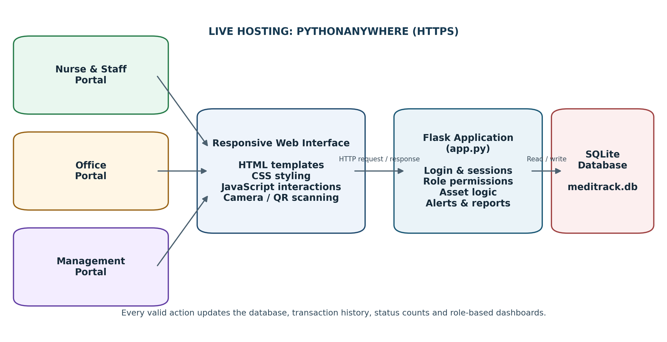
Figure 4.1. Flask – SQLite system architecture of AssetTrack
Table 4.1 System architecture layers and components
Layer / component | Implementation | Purpose
User interface | HTML templates (Jinja2) | Login pages, dashboards, forms, scan screens, tables and reports
Styling and interaction | CSS and JavaScript (static folder) | Responsive layout, camera scanning, validation, dynamic displays and alerts
Application server | Python Flask (app.py) | Routes, sessions, permissions, business rules, asset actions and report generation
Database | SQLite (meditrack.db) | Stores users, assets, locations, transactions, return requests, maintenance, messages and emergencies
Local environment | .venv and requirements.txt | Keeps required Python packages isolated and reproducible
Cloud hosting | PythonAnywhere | Runs the Flask application through a public HTTPS link
4.2 System Users and Permissions
Table 4.2 System users, portals and permitted actions
Portal | Main responsibilities | Typical permitted actions
Nurse & Staff | Daily asset use and field updates | Login, scan assets, take, return, transfer, view assigned assets, respond to return requests, report damage, read/send messages and acknowledge emergencies
Office | Operational control and master-data management | Create employees, categories, asset types and assets; generate/view QR codes; monitor holders, locations, status, low availability, maintenance, messages and reports
Management | Hospital-wide oversight and decisions | View totals, graphs, recent transactions, asset availability, delayed/maintenance/missing assets, emergency history and consolidated reports
4.2.1 Login Process
1. The user opens the live AssetTrack website.
2. The user selects the correct portal: Nurse & Staff, Office or Management.
3. The user enters the assigned User ID and password.
4. The Flask backend checks the account, password and selected role.
5. After successful verification, the server creates a login session and opens the correct dashboard.
6. Protected pages reject users who do not have the required role.
7. The user logs out after completing the work.
Important for real use
Every employee should have an individual account. Shared demonstration accounts should not be used in a real hospital because the system must accurately identify who took, returned, transferred or reported an asset.
4.3 Complete System Working Process
Overall working sequence
Login → identify or scan asset → confirm location/action → validate permission and current status → save transaction in SQLite → update asset state and counts → show the result on Staff, Office and Management dashboards.

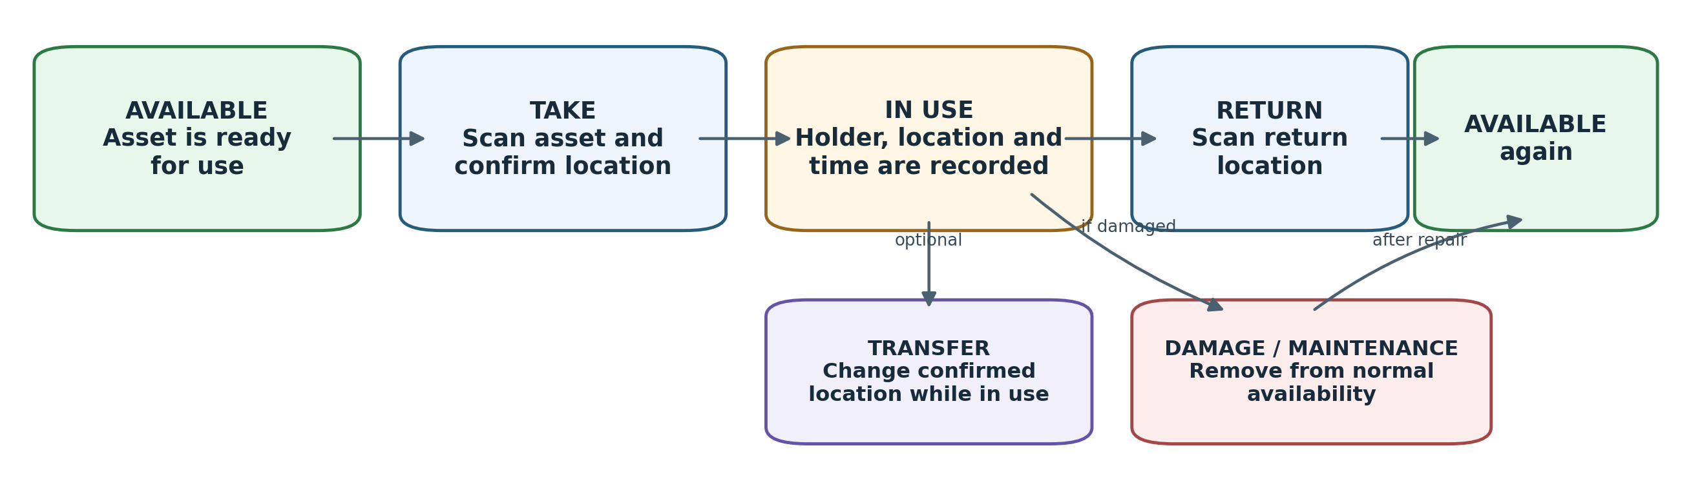
Figure 4.2. Normal asset lifecycle and exception paths
4.3.1 Initial System Setup
1. Office users create hospital departments and authorised locations.
2. Asset categories and asset types are created, including minimum available quantity and expected return time.
3. Each physical asset is added with a unique Asset ID and QR value.
4. A QR label is printed and fixed to the corresponding equipment.
5. Location QR labels are placed at authorised rooms, parking areas, stores and maintenance areas.
6. Individual employee accounts are created and assigned the correct role and department.
4.3.2 Taking an Asset
1. The staff member logs in and opens the asset scan or asset action page.
2. The asset QR code is scanned; the system loads the asset name, ID, current status, condition and latest location.
3. The user scans or selects the destination/current hospital location.
4. The user selects TAKE and may enter an optional reason or expected return information.
5. The backend checks that the asset is available and the user is authorised.
6. The database records the employee, asset, location, action and time.
7. The asset changes from Available to In Use; the current holder is assigned and the available count decreases.
4.3.3 Returning an Asset
1. The current holder scans or selects the asset.
2. The correct return location or parking/store location is scanned or selected.
3. The user selects RETURN.
4. The backend verifies the holder and records the return transaction.
5. The holder field is cleared, the returned time and location are stored, and the status changes to Available.
6. Any open return request for that asset is completed and dashboard counts increase immediately.
4.3.4 Transferring an Asset
TRANSFER is used when an asset remains in use but moves to another authorised location or responsible employee. The new location and transfer details are recorded without incorrectly marking the asset as available, and the complete transfer remains visible in the transaction history for traceability.
4.3.5 Reporting Damage or Maintenance
1. The user selects REPORT DAMAGE and enters the issue description.
2. The system changes the asset to a maintenance-related state and removes it from the normal available quantity.
3. Office users inspect the issue, update the maintenance stage and record completion.
4. After repair and approval, the asset is restored to an authorised location and changed back to Available.
4.3.6 Management Monitoring
1. Management opens the dashboard to view total registered assets and current status distribution.
2. The user can identify available, in-use, return-requested, delayed, maintenance and missing assets.
3. Recent movement records show the asset, employee, department, location, action and time.
4. Reports and graphs help management identify high-use assets, shortages, delays and maintenance requirements.
4.4 Automatic Availability and Return Logic
Each asset type can store a minimum available quantity. The system compares the current available count with this minimum so that shortages can be recognised early.
State | Description
Normal availability | Available count is equal to or higher than the configured minimum.
Low availability | Available count falls below the configured minimum and the asset type is highlighted for attention.
Return request | The system or Office user contacts eligible holders, generally starting with assets taken earliest.
NEED response | The employee confirms that the asset is still required and enters the reason or expected return information.
RETURN response | The employee commits to return the asset within a selected time; the promised return time is stored.
Table 4.3 Availability and return-request states

Why this feature is intelligent
The system does not only store asset records. It compares actual availability with a configured minimum, identifies shortages and supports the recovery of assets that are already in use.
4.5 Messaging, Emergency and Maintenance
4.5.1 Internal Messages
- Users can exchange operational messages between employees, departments or roles.
- Messages can be marked Normal, Urgent or Emergency priority.
- Unread indicators and visual emphasis help the receiver notice important information while the website is open.
- Message records preserve the sender, receiver/target, priority, content and time.
4.5.2 Emergency Alerts
1. An authorised user selects the emergency type, location and description.
2. The alert is stored once and becomes visible to all permitted portal types.
3. Receivers acknowledge the alert using the available response options.
4. Office or Management closes the alert after the situation is controlled.
5. The emergency history remains available for later review.
4.5.3 Maintenance Record
- Every damage report is linked to the exact asset instead of being stored as an unrelated complaint.
- The asset is prevented from appearing as normally available while repair is pending.
- Issue description, reporter, stage and completion information form a maintenance history.
- Management can use this history to identify frequently failing assets and replacement needs.

CHAPTER 6
SYSTEM DEVELOPMENT AND IMPLEMENTATION
6.1 Module-by-Module Development Process
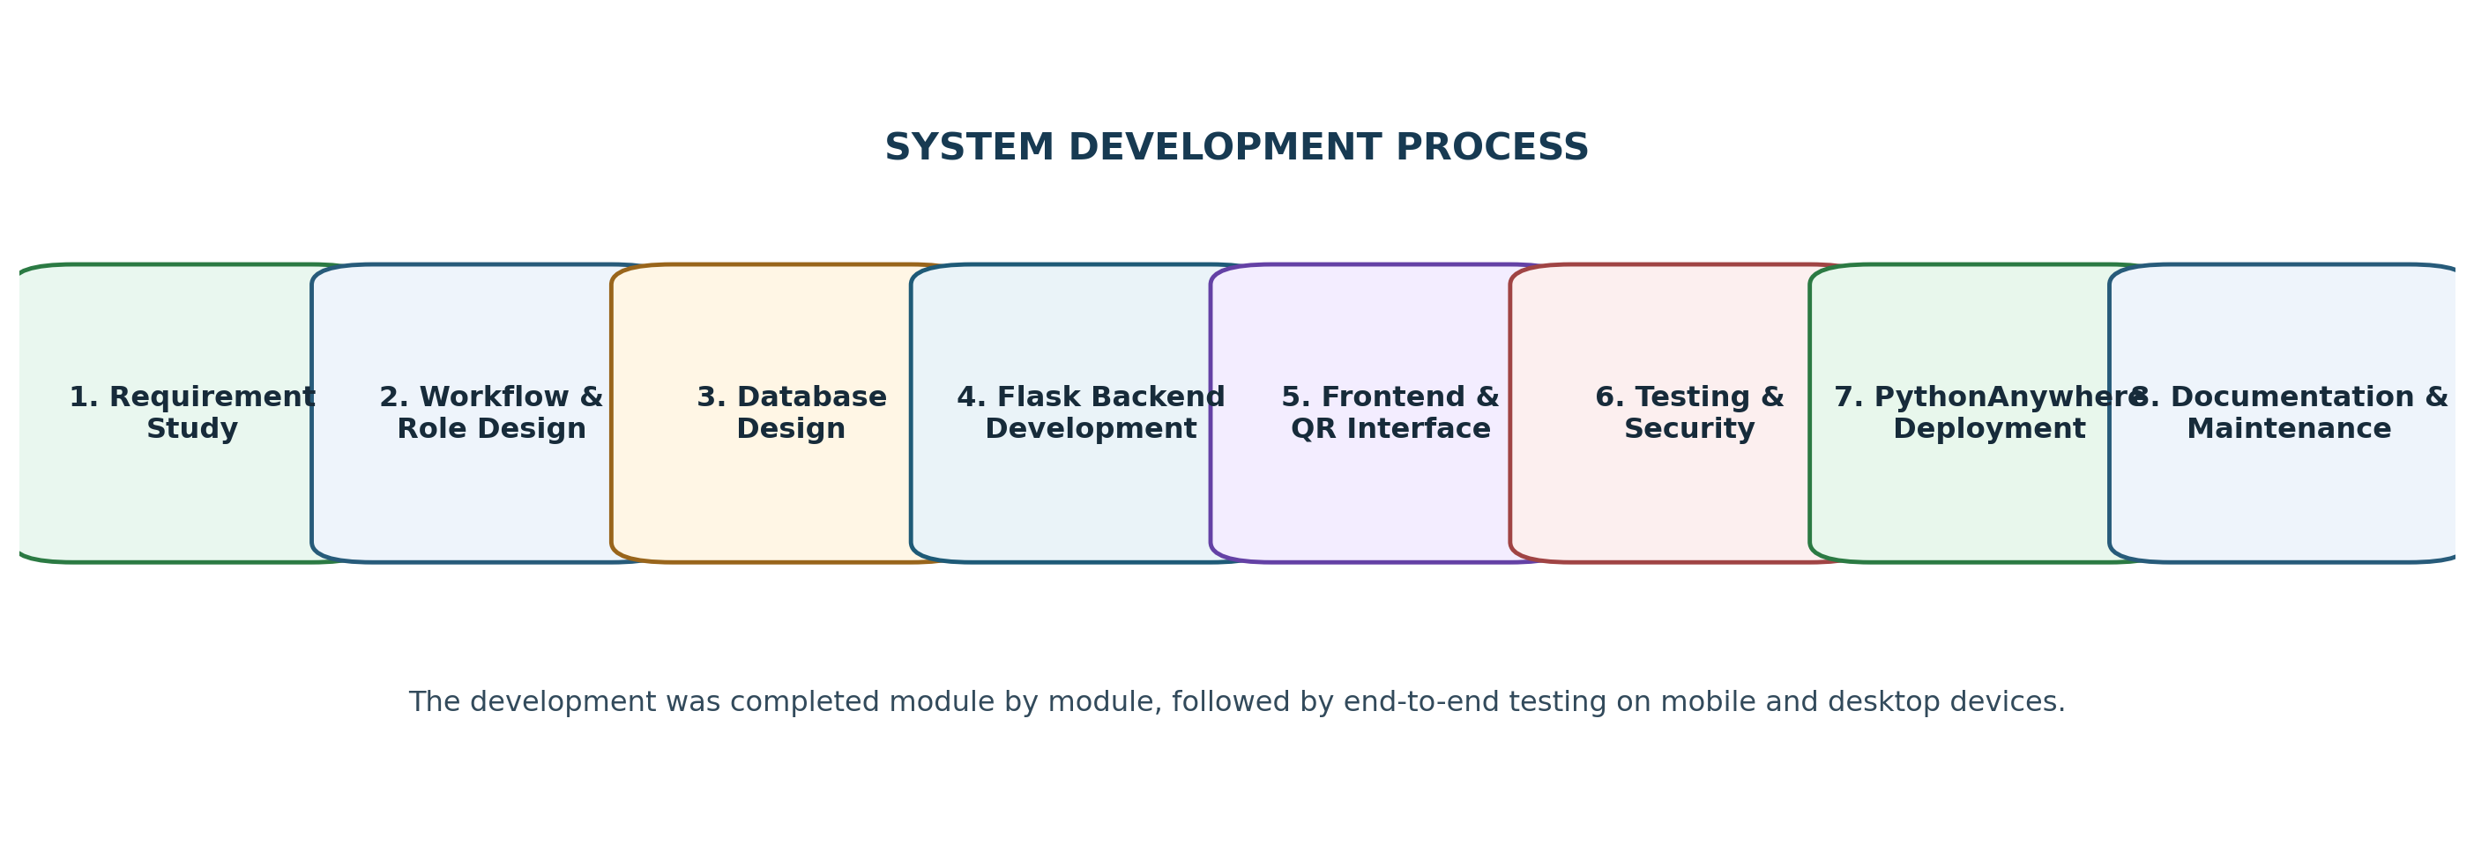
Figure 6.1. Module-by-module development process
6.1.1 Requirement Study
The hospital problem, target assets, user roles, required actions, reports and operating devices were identified. The key decision was to use QR scan-based latest-location confirmation instead of expensive GPS or RFID hardware.
6.1.2 Workflow and Role Design
Separate workflows were defined for Staff, Office and Management. Asset states and allowed transitions were mapped before coding so that invalid actions, such as taking an already in-use asset, could be rejected.
6.1.3 Database Design
SQLite tables were designed for users, departments, locations, categories, asset types, individual assets, transactions, return requests, maintenance, messages and emergencies, linked using IDs.
6.1.4 Flask Backend Development
The app.py file was developed as the main application. Flask routes receive browser requests, verify login sessions and roles, read or update SQLite records, apply asset rules and render the correct HTML template.
6.1.5 Frontend Development
HTML pages were created in templates, while CSS and JavaScript were placed in static. The interface was made responsive so the same system can be used on a phone for scanning and on a laptop for monitoring.
6.1.6 QR and Camera Integration
Unique QR values were connected to asset and location records. JavaScript camera scanning reads the code, sends the identifier to Flask and displays the matching record.
6.1.7 Authentication and Permissions
Different login routes and role checks were created, along with password hashing, session management, logout, account status and password-reset support.
6.1.8 Reports and Alerts
Status counts, recent transaction tables, graphs, return-request logic, messages, emergencies and maintenance screens were added after the core take/return workflow became stable.
6.1.9 Local Testing
The project was run locally using the virtual environment and START_MEDTRACK.bat. Mobile camera testing was supported through the secure mobile-link batch file, and functional tests were completed for every role and status change.
6.1.10 Deployment
The Flask application was configured on PythonAnywhere, dependencies were installed from requirements.txt, the WSGI configuration was connected to app.py, and the database and static/template folders were uploaded.
6.1.11 Documentation and Maintenance
README.md explains setup and operation, UPDATE_NOTES.txt records changes, app.zip stores a backup copy, and reset_password.py supports account recovery.
6.2 Database Design
AssetTrack follows a straightforward design rule: the assets table always stores only the current state of each asset, while the transactions table stores the complete movement history. This keeps dashboards fast to query while preserving a full, traceable audit trail of every action.
Table 6.1 Main database tables and purpose
Table | Important fields | Purpose
users | id, user_id, name, password_hash, role, department_id, active | Login identity and role
departments | id, code, name | Hospital department master data
locations | id, code, name, department_id, qr_value | Rooms, stores and parking locations
asset_types | id, name, code, minimum_available, expected_return_minutes | Asset family rules
assets | id, asset_id, qr_value, status, condition, holder_id, location_id | Current state of each physical asset
transactions | asset_id, user_id, action, from_location, to_location, created_at | Permanent movement history
return_requests | asset_id, holder_id, response, promised_return_at, status | Low-availability return process
maintenance | asset_id, issue, reporter_id, stage, completed_at | Damage and repair history
messages | sender_id, target, priority, subject, body, seen | Internal communication
emergencies | type, location_id, description, reporter_id, status | Hospital-wide emergency records
6.2.1 Core SQLite schema (representative excerpt)
CREATE TABLE IF NOT EXISTS users (
id INTEGER PRIMARY KEY AUTOINCREMENT,
user_id TEXT UNIQUE NOT NULL,
employee_name TEXT NOT NULL,
password_hash TEXT NOT NULL,
role TEXT NOT NULL CHECK (role IN ('staff','office','management')),
department_id INTEGER,
is_active INTEGER NOT NULL DEFAULT 1,
created_at TEXT NOT NULL DEFAULT CURRENT_TIMESTAMP
);

CREATE TABLE IF NOT EXISTS assets (
id INTEGER PRIMARY KEY AUTOINCREMENT,
asset_id TEXT UNIQUE NOT NULL,
asset_type_id INTEGER NOT NULL,
qr_value TEXT UNIQUE NOT NULL,
current_holder_id INTEGER,
current_location_id INTEGER,
status TEXT NOT NULL DEFAULT 'available',
condition_status TEXT NOT NULL DEFAULT 'good',
taken_at TEXT,
expected_return_at TEXT,
updated_at TEXT NOT NULL DEFAULT CURRENT_TIMESTAMP,
FOREIGN KEY (current_holder_id) REFERENCES users(id),
FOREIGN KEY (current_location_id) REFERENCES locations(id)
);

CREATE TABLE IF NOT EXISTS transactions (
id INTEGER PRIMARY KEY AUTOINCREMENT,
asset_id INTEGER NOT NULL,
user_id INTEGER NOT NULL,
action TEXT NOT NULL,
from_location_id INTEGER,
to_location_id INTEGER,
notes TEXT,
created_at TEXT NOT NULL DEFAULT CURRENT_TIMESTAMP,
FOREIGN KEY (asset_id) REFERENCES assets(id),
FOREIGN KEY (user_id) REFERENCES users(id)
);
Database rule
The assets table stores only the current state. The transactions table stores the complete history. Therefore dashboards are fast to load and every previous movement remains traceable.
6.3 Project Folder and File Structure
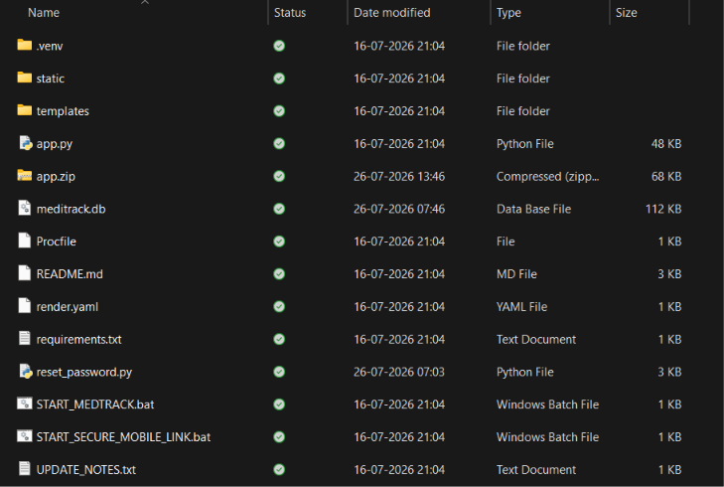
Figure 6.2. Completed project folder used for local development and deployment
Table 6.2 Project folder and file explanation
File / Folder | Type | Purpose
.venv | Folder | Local Python virtual environment containing isolated project packages
static | Folder | CSS, JavaScript, icons, images and other browser assets
templates | Folder | Flask HTML pages for home, login, dashboards, scan screens and reports
app.py | Python | Main Flask application: routes, authentication, business logic and database access
app.zip | Archive | Backup or transferable copy of the application
meditrack.db | SQLite database | Stores the complete operational data of the system
Procfile | Deployment file | Start-command configuration for Render/Heroku-style hosting
render.yaml | YAML | Alternative Render deployment configuration retained in the project
requirements.txt | Text | List of Python libraries required to run the application
README.md | Documentation | Project setup, run and usage instructions
reset_password.py | Python utility | Administrative password recovery/reset support
START_MEDTRACK.bat | Windows batch | Starts the local Flask application quickly on Windows
START_SECURE_MOBILE_LINK.bat | Windows batch | Starts a secure mobile-access link for camera/QR testing
UPDATE_NOTES.txt | Text | Records modifications, fixes and version notes
6.4 Request Flow and User Interface
Every user action in AssetTrack – a click, a form submission or a QR scan – follows the same coding path from the browser through to the database and back, which keeps the system predictable and easy to debug.
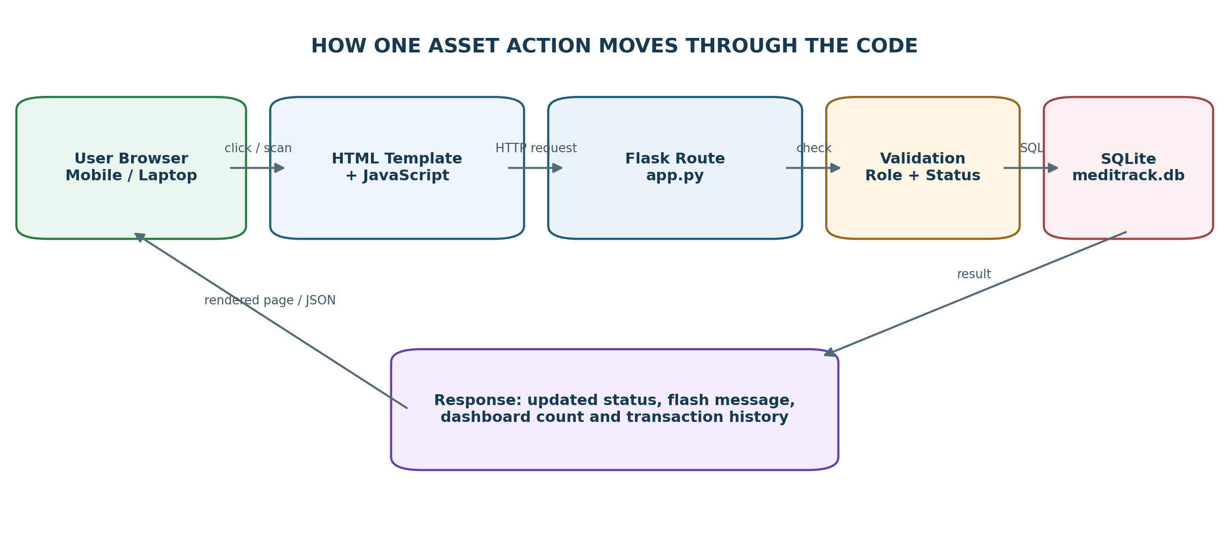
Figure 6.3. How one asset action moves through the code, from browser to database and back
1. The user submits a form or scans a QR code in an HTML page.
2. JavaScript validates the basic input and sends the request to a Flask route.
3. The Flask route checks the session, portal role, asset status and required fields.
4. SQL reads or updates meditrack.db inside a controlled transaction.
5. The route records the action history and returns a page redirect or JSON response.
6. The browser shows the new status and the dashboards read the updated counts.
6.4.1 Main Interface Screens
- Home page – presents the AssetTrack name and three portal buttons (Nurse & Staff, Office, Management) leading to the matching login form.
- Login page – collects the User ID and password for the selected portal and shows a clear error when the credentials or role do not match.
- Staff scan / action page – activates the device camera, decodes the asset QR code, displays the asset's current status and location, and presents Take / Return / Transfer / Report Damage buttons appropriate to that status.
- Staff dashboard – lists assets currently assigned to the logged-in employee and any pending return requests awaiting a NEED / RETURN response.
- Office dashboard – shows master-data management (employees, departments, locations, asset types, assets), current holders/locations, low-availability warnings and maintenance queues.
- Management dashboard – presents status totals, graphs, the most recent transactions, delayed/maintenance/missing asset lists and downloadable reports.

CHAPTER 7
RESULT AND DISCUSSION
7.1 Testing and Demonstration Procedure
The completed system was tested functionally for every user role and every asset state transition, using at least two separate accounts and browser sessions to confirm that concurrent actions are handled safely.
Test | Action | Expected result
Portal login | Login using each role through its correct portal | Correct dashboard opens; wrong role is rejected
Take asset | Scan/select an available asset and choose TAKE | Status becomes In Use and holder/location/time are recorded
Duplicate take | Try to take an asset already in use | System blocks the invalid second assignment
Return asset | Return the same asset at an authorised location | Holder clears, status becomes Available and count increases
Transfer | Move an in-use asset to another location | Location/history update while asset remains In Use
Damage report | Report a fault for an available or in-use asset | Asset changes to maintenance-related state and issue is recorded
Low availability | Reduce available quantity below the minimum | Low-availability warning/return process appears
Return promise | Respond RETURN with a time, then allow it to pass | Return Requested changes to Delayed if not returned
Messages | Send a message from one role/device to another | Receiver sees the correct message and priority
Emergency | Create and acknowledge an emergency alert | Permitted portals receive it and acknowledgements are stored
Reports | Open dashboard/history and generate a report/export | Counts and records match the performed transactions
Responsive/camera | Test on phone, tablet and laptop | Pages remain usable and camera works through HTTPS permission
Table 7.1 Functional test cases and expected results

7.1.1 Demonstration Scenario
- Office selects a wheelchair record, for example WC-004, and confirms its QR code and default parking location.
- A Staff user scans WC-004, selects ICU 1 and chooses TAKE; Office confirms that it is In Use under the correct employee.
- Management checks the available count and recent transaction; the Staff user then demonstrates a transfer or return-request response.
- The Staff user returns WC-004 to Wheelchair Parking, so the status becomes Available and the full history remains stored.
- Another demo asset is used to show damage/maintenance, followed by a message and an emergency acknowledgement.
7.2 Results and Discussion
The completed AssetTrack application successfully demonstrated end-to-end identification, assignment and recovery of hospital assets using only QR-code scanning and a standard web browser. Every functional test listed in Table 7.1 produced the expected result, confirming that role-based access control, asset status validation and transaction logging behave correctly under normal use and under attempted invalid actions such as taking an already in-use asset.
The Take → In Use → Return → Available cycle, together with the Transfer and Damage/Maintenance exception paths, correctly updated the current holder, location and status for every tested asset, and the corresponding entry was always visible in the transaction history reviewed from the Office and Management dashboards. The automatic availability logic correctly flagged asset types as low-availability once their available count fell below the configured minimum, and delayed-return detection correctly changed status from Return Requested to Delayed once a promised return time passed without action.
Messaging and emergency alert features were confirmed to reach the intended portals with the correct priority level, and acknowledgements were correctly stored against the emergency record. Camera-based QR scanning worked reliably on mobile devices once HTTPS and camera permission were granted, and a manual code-entry fallback remained available for situations where scanning was not possible.
Overall, the results confirm that a browser-based, QR-driven approach can reliably replace manual, notebook-based asset tracking in a hospital setting. The system gives Nurse & Staff, Office and Management users a single, consistent and traceable view of asset availability, reduces the time required to locate shared equipment, and exposes shortages and delays before they affect patient care – achieving the objectives set out in Chapter 1 without the cost of RFID, BLE or GPS-based hardware infrastructure.

CHAPTER 8
SCOPE OF FUTURE WORK
Advantages | Current limitations | Future improvements
Low-cost, browser-based; no dedicated tracking hardware; complete auditable history; role-based access; automatic shortage/delay alerts. | Shows the latest confirmed location rather than continuous live movement; camera scanning needs HTTPS; SQLite needs planning for very large deployments. | RFID/BLE positioning; native mobile app; PostgreSQL/MySQL migration; predictive maintenance; HIS integration.
Table 8.1 Advantages, limitations and future improvements

Beyond the improvements summarised above, the following specific directions can extend the system further:
- RFID, BLE or UWB-based positioning can be added for continuous real-time location instead of latest-scan confirmation.
- Push notifications or a native mobile app can replace browser-only alerts for faster staff response.
- The database can be migrated from SQLite to PostgreSQL or MySQL to support a larger number of concurrent users and assets.
- Predictive maintenance scheduling can be added using the accumulated maintenance history of each asset type.
- Analytics and usage-pattern dashboards can help forecast asset procurement needs across departments.
- Integration with an existing Hospital Information System (HIS) can unify asset records with patient-care workflows.
- Audit-log export and automated cloud backup can strengthen compliance and disaster recovery.
8.1 Advantages
- Low-cost browser-based system; no specialised tracking hardware required.
- Role-based access keeps Staff, Office and Management functions clearly separated.
- Complete, tamper-evident movement history for every asset.
- Faster asset search and reduced idle staff time.
- Automatic shortage and delayed-return warnings.
- Linked maintenance and management reporting.

8.2 Limitations
- Shows the latest confirmed location rather than continuous live movement.
- Camera-based scanning requires HTTPS and browser camera permission.
- Browser-based alerts may stop when the device browser is closed.
- SQLite requires regular backup and careful planning before scaling to very large deployments.
8.3 Applications
- General hospitals and multi-speciality medical centres.
- Diagnostic centres and standalone clinics with shared portable equipment.
- Ambulance services tracking transportable emergency equipment.
- Educational and training hospitals for equipment accountability.
- Any institution requiring low-cost, auditable tracking of reusable movable assets.

CHAPTER 9
APPENDICES
Appendix – 1 Login Credentials
The following demonstration accounts were configured for evaluation of the live AssetTrack deployment. In real hospital use, shared demonstration accounts must be replaced with individual employee accounts as noted in Section 4.2.
Live website: https://assettrack.pythonanywhere.com
Role / Access Level | Username | Password
Nurse & Staff | medwork001 | 12345678
Nurse & Staff | medwork002 | 12345678
Office Staff | office123 | 12345678
Management | management123 | 12345678
Appendix – 2 Database Schema Specification
Complete field-level specification of the core SQLite tables used by AssetTrack.
Table | Key fields | Notes
users | id (PK), user_id (unique), employee_name, password_hash, role, department_id, is_active, created_at | role restricted to staff / office / management
departments | id (PK), code, name | Master data created by Office
locations | id (PK), code, name, department_id (FK), qr_value (unique) | Includes rooms, stores and parking points
asset_types | id (PK), name, code, minimum_available, expected_return_minutes | Defines shortage threshold and expected return time
assets | id (PK), asset_id (unique), asset_type_id (FK), qr_value (unique), current_holder_id (FK), current_location_id (FK), status, condition_status, taken_at, expected_return_at, updated_at | Stores only the current state of each asset
transactions | id (PK), asset_id (FK), user_id (FK), action, from_location_id, to_location_id, notes, created_at | Append-only movement history
return_requests | id (PK), asset_id (FK), holder_id (FK), response, promised_return_at, status | Drives the low-availability return workflow
maintenance | id (PK), asset_id (FK), issue, reporter_id (FK), stage, completed_at | Damage and repair history
messages | id (PK), sender_id (FK), target, priority, subject, body, seen, created_at | Internal communication log
emergencies | id (PK), type, location_id (FK), description, reporter_id (FK), status | Hospital-wide emergency record
Appendix – 3 Pseudo Code for Key Functions
The following structured pseudocode summarises the core Take-Asset operation implemented in the Flask backend (app.py), simplified from the actual source code for presentation purposes.
A3.1 Take Asset Operation
BEGIN Take_Asset(asset_id, location_id, user)
IF asset_id or location_id is missing THEN
SHOW "Asset and location are required"; RETURN
END IF

asset ← SELECT asset record FROM assets WHERE id = asset_id
IF asset NOT FOUND THEN
SHOW "Asset not found"; RETURN
END IF

IF asset.status ≠ 'available' THEN
SHOW "This asset is not currently available"; RETURN
END IF
IF asset.condition NOT IN {'good','minor_damage'} THEN
SHOW "This asset cannot be issued in its current condition"; RETURN
END IF

expected_return ← now() + asset_type.expected_return_minutes

BEGIN TRANSACTION
UPDATE assets SET status='in_use', holder=user,
location=location_id, taken_at=now(),
expected_return_at=expected_return
WHERE id = asset_id AND status = 'available'
INSERT INTO transactions(asset_id, user, action='take',
from_location, to_location, time=now())
COMMIT TRANSACTION

SHOW "Asset issued successfully"
END Take_Asset

A3.2 Automatic Low-Availability and Delay Check
BEGIN Check_Availability_And_Delays()
FOR EACH asset_type IN asset_types DO
available_count ← COUNT(assets WHERE type = asset_type
AND status = 'available')
IF available_count < asset_type.minimum_available THEN
FLAG asset_type AS 'low_availability'
CREATE return_request FOR earliest-taken asset(s)
END IF
END FOR

FOR EACH asset IN assets WHERE status IN
('in_use','return_requested') DO
IF asset.expected_return_at < now() THEN
SET asset.status = 'delayed'
END IF
END FOR
END Check_Availability_And_Delays
A3.3 Role-Based Access Check (applied to every protected route)
BEGIN Roles_Required(allowed_roles)
IF current_user is NOT logged in THEN
REDIRECT to home page; RETURN
END IF
IF current_user.role NOT IN allowed_roles THEN
RETURN HTTP 403 Forbidden
END IF
PROCEED to requested page
END Roles_Required
Appendix – 4 System Development and Coding Checklist
Area | Checklist
Configuration | Production SECRET_KEY is not written directly in app.py
Passwords | All passwords are stored using generate_password_hash
Queries | All user-supplied values use SQL ? parameters (no string concatenation)
Sessions | Every protected page checks login and role before rendering
Asset rules | Take, Return, Transfer and Damage validate the current status before writing
Transactions | Every successful movement creates a transaction history record
Database writes | Multi-step actions commit together or roll back together
Camera | HTTPS and a manual-code fallback are provided for QR scanning
Errors | Users receive clear messages without exposing database internals
Deployment | Debug mode is disabled and database backup is maintained
CHAPTER 10
CONCLUSION
This project successfully demonstrated the design, development and deployment of AssetTrack, an Intelligent Hospital Asset Tracking and Management System built using a Python Flask backend, an SQLite database and a QR-code-driven browser interface. The main objective was to give a hospital a low-cost, common system to identify reusable assets, record who is using each asset, confirm its latest location, control availability, support timely returns, report damage and provide clear management reports – without relying on expensive RFID, BLE or GPS tracking hardware.
Separate role-based portals for Nurse & Staff, Office and Management ensured that each user group could access only the functions relevant to their responsibilities, while every take, return, transfer and damage action was recorded as a permanent, auditable transaction. The automatic low-availability and delayed-return logic proved effective in surfacing shortages and overdue assets before they could disrupt hospital operations, and the messaging and emergency-alert modules extended the system beyond simple tracking into a broader operational communication tool.
Functional testing across all user roles and asset states confirmed that the system behaves correctly under both normal use and attempted invalid actions, and that the responsive interface performs reliably across mobile, tablet and desktop devices. The live HTTPS deployment on PythonAnywhere demonstrated that the complete solution can be hosted and operated at low recurring cost, making it a practical option for hospitals, clinics and other institutions that need dependable, low-cost tracking of shared, reusable equipment.
Overall, this project confirms that a software-only, QR-based approach, when combined with careful workflow design, role-based access control and automatic availability logic, can deliver most of the operational benefit of costlier hardware-based asset tracking systems, while remaining affordable and easy to deploy for resource-constrained healthcare institutions. Future enhancements such as RFID/BLE positioning, native mobile applications, predictive maintenance and HIS integration, discussed in Chapter 8, provide a clear roadmap for extending the system's capability.

REFERENCES

[1] Chang, V., & Black, K. (2022). Impact of Hospital Characteristics and Governance Structure on the Adoption of Tracking Technologies for Clinical and Supply Chain Use: Longitudinal Study of US Hospitals. Journal of Medical Internet Research, 24(5), e33742.
[2] Understanding the RFID Deployment at Sacred Heart Medical Center: Using Technology-Organization-Environment Framework Lenses. (2022). Procedia Computer Science, 196, 445–453. https://doi.org/10.1016/j.procs.2021.12.035
[3] Moonsrikaew, P., Sitawan, S., & Chatsermsak, P. (2023). Online Asset Monitoring System Using QR Code Technology. Journal of Organizational Innovation & Culture.
[4] Azriani, F., & Frendiana, V. (2024). Perancangan Website Life Cycle Management untuk Optimalisasi Aset dengan QR Code Reader. Seminar Nasional Teknik Elektro.
[5] Azzahra, Z. F., & Suakanto, S. (2025). A Barcode-Based Medical Asset Management System with Integrated Monitoring in Hospitals. JUSIFO (Jurnal Sistem Informasi), 11(1), 21–30. https://doi.org/10.19109/jusifo.v11i1.25268
[6] Sitanggang, J. A., Saputra, B. H., Hidayati, A., & Saragih, H. (2026). Design and Development of the SpaceLog Web Application for Inventory Management and Asset Tracking Using QR Codes. Jurnal Mandiri IT, 14(3). https://doi.org/10.35335/mandiri.v14i3.481
[7] Fisher, J. A., & Monahan, T. (2008). Tracking the Social Dimensions of RFID Systems in Hospitals. International Journal of Medical Informatics, 77(3), 176–183.
DOI: 10.1016/j.ijmedinf.2007.05.005

